**About Data:**

The data consist of 1000 record of people demographic data and wither they have a bike or no, and here is a snapshot of data:

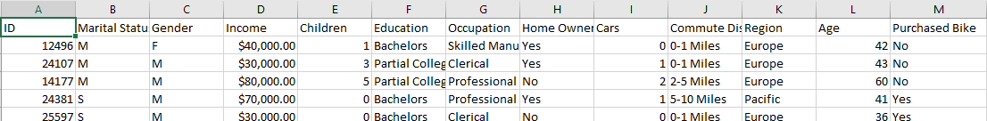

**Data Cleaning and Preparation:**

* 25 duplicated people data founded and deleted.
* no missing data funded
* Standardized variables of Gender and Marital Status (changed M/F to Male/Female and S/M to Single and Married)
* The income format Changed to number instead of currency to avoid in calculation errors.
* A new column (Age Range) create to categories the customer ages (Adolescent <31, Mid age >= 31, old >54)

snapshot for data after Cleaning and Preparation:

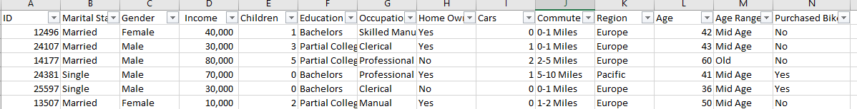

**Exploratory Analysis Performed:**

* Percentage of people who buy a bike to who didn’t.
* The Average Income
* Average of ages
* Box-Plot for Income to detect outliers

**Visualization:**

* Pie Chart: Percentage of people who buy a bike to who didn’t.
* Line Chart: Age Range and Purchased Bike
* Line Chart: Commute Distance and Purchased Bike
* Bar Chart: Marital status, gender and Purchased Bike
* Line Chart: Children numbers and Purchased Bike
* Line Chart: Car Number and Purchased Bike
* Line Chart: Income and Purchased Bike

**Key Findings & Insights:**

* Income is a strong predictor: people with mid and low income are more likely to purchase a bike
* ­Middle aged customer purchased a car more than others
* shorter commute indicted more tendency to purchase bike.
* Occupation & Education: Customers with professional jobs and higher education levels purchase bikes more frequently.
* Gender and marital state: Males are more likely to purchase a bike than females whatever the marital state.
* Children number: negative relation between children number and purchase bike chance.